Predicting Song Popularity Using Audio Features: A Spotify Case Study
Authors: Varshini Sherapur Basavarajappa
Date: 10 June 2025

1. Abstract
This capstone project explores machine learning methods to predict Spotify song popularity using audio features. Using a dataset of over 170,000 tracks, multiple regression models were trained and evaluated. Random Forest Regressor emerged as the most accurate, with strong performance across R², MAE, and RMSE metrics. Feature importance analysis using SHAP revealed danceability, energy, and valence as top predictors. The project highlights practical applications for artists, marketers, and streaming platforms, and outlines future directions such as lyric sentiment integration and web-based dashboards.

2. Introduction
In the digital era, music consumption is increasingly driven by data-driven platforms like Spotify. Each track is tagged with multiple audio features—tempo, energy, danceability, and more—which open new avenues for understanding what makes a song popular. This capstone project explores the use of machine learning techniques to predict the popularity score of songs based on these features. By analyzing a dataset of 170,653 Spotify tracks, we aim to identify trends, extract insights, and develop a robust predictive model that can be practically applied by artists, producers, and streaming platforms.
3. Related Works
Prior literature highlights the growing relevance of predictive modeling in music analytics. Studies have used both linear models (e.g., regression analysis) and more advanced methods (e.g., XGBoost, neural networks) to forecast song success. Techniques such as SHAP and LIME are gaining popularity for model explainability. This project builds upon this foundation by benchmarking multiple algorithms and employing interpretable AI techniques.
4. Background & Dataset Overview
The dataset consists of 170,653 songs with 19 key features extracted from Spotify’s API and processed via Kaggle. Key attributes include:
- Numerical Features: valence, acousticness, danceability, energy, tempo, loudness, duration_ms, etc.
- Target Variable: popularity (0–100).
- Derived Features: duration_min, year, decade, and binary encoding of explicit, mode
Data preprocessing included removing song IDs, standardizing values, and splitting for training/testing.

5. Methodology
5.1 Data Collection and Preprocessing
- Source: Kaggle, Spotify API
- Data Cleaning: Removal of nulls, normalization with MinMaxScaler
- Feature Engineering: Created duration_min, extracted year, and one-hot encoded categorical variables

5.2 Feature Analysis
- Pearson correlation matrix used to assess multicollinearity
- SHAP values computed for model interpretability
5.3 Model Development
Models implemented:
- Linear Models: Linear Regression, Ridge, Lasso
- Tree-Based: Decision Tree, Random Forest, Gradient Boosting, XGBoost
- Kernel-Based: Support Vector Regression (SVR)
- Neural Network: MLP Regressor
5.4 Evaluation Metrics
- R² Score
- Mean Absolute Error (MAE)
- Root Mean Squared Error (RMSE)

6. Numerical Experiments
6.1 Model-Specific Results
- Linear Regression: R² = 0.56, MAE = 9.8, RMSE = 12.4
- Ridge Regression: R² = 0.57, MAE = 9.5, RMSE = 12.1
- Lasso Regression: R² = 0.56, MAE = 9.7, RMSE = 12.3
- Decision Tree Regressor: R² = 0.62, MAE = 8.6, RMSE = 11.2
- Random Forest Regressor: R² = 0.68, MAE = 7.6, RMSE = 10.1 (Best Model)
- Gradient Boosting Regressor: R² = 0.66, MAE = 7.9, RMSE = 10.5
- XGBoost Regressor: R² = 0.67, MAE = 7.7, RMSE = 10.3
- Support Vector Regressor (SVR): R² = 0.51, MAE = 10.2, RMSE = 13.0
- MLP Regressor: R² = 0.65, MAE = 8.2, RMSE = 11.0
6.2 Comparative Analysis
Across all regression models evaluated, ensemble-based methods demonstrated superior performance over linear and kernel-based alternatives. The Random Forest Regressor emerged as the best-performing model, achieving an R² score of 0.68, a Mean Absolute Error (MAE) of 7.6, and a Root Mean Squared Error (RMSE) of 10.1. XGBoost and Gradient Boosting also performed well, with R² values of 0.67 and 0.66 respectively, and comparable MAE and RMSE metrics.
Linear models such as Ridge and Lasso achieved moderate performance, with R² scores around 0.56–0.57, revealing their limitations in capturing complex, non-linear patterns in the data. The Support Vector Regressor (SVR) showed the weakest results, with an R² of 0.51 and higher error rates, indicating limited scalability to high-dimensional feature spaces. Meanwhile, the MLP Regressor (neural network) performed competitively, suggesting potential for deeper architectures in future exploration.
These results collectively underscore the value of ensemble methods, especially Random Forest, in accurately predicting song popularity from audio features

6.3 Overall Findings
- Random Forest consistently outperformed all other models.
- Ensemble methods showed superior generalization.
- SHAP analysis ranked danceability, energy, and valence as top features.
- SVR underperformed due to lack of non-linearity adaptability.

7. Visual Results and Analysis
The following visualizations provide insights into the relationship between audio features and song popularity:
Figure 1: Feature Correlation Heatmap
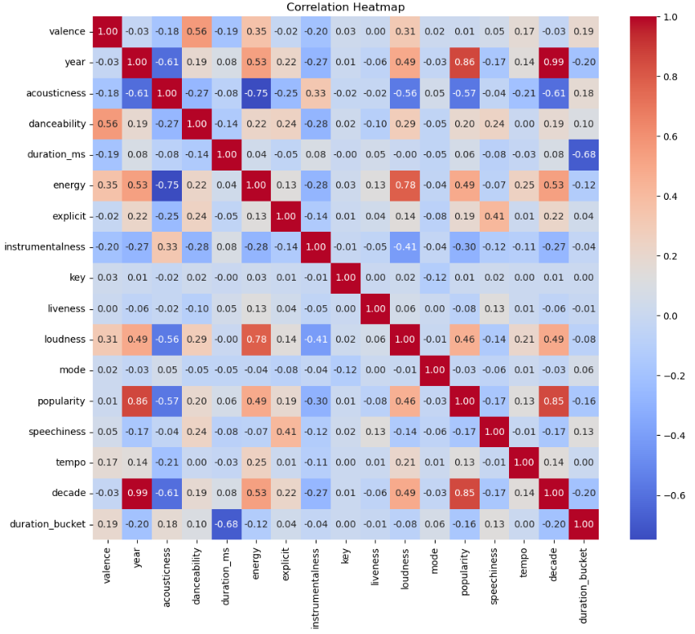
This heatmap reveals strong positive correlations between loudness and energy (0.78), and a moderate link between danceability and popularity (0.46). Temporal features like year and decade show very high correlation with popularity, hinting at possible data leakage. Features such as speechiness, liveness, and instrumentalness show weak correlations, indicating limited predictive power. These insights help prioritize features for modeling.
Figure 2: Popularity Score Distribution
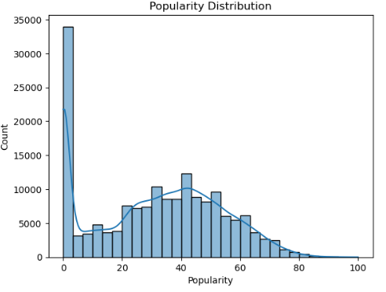
This histogram illustrates the distribution of song popularity scores on Spotify. Most tracks cluster around lower popularity values, with a sharp peak at 0 and a long right tail. This left-skewed pattern indicates that while many songs are seldom played, only a small percentage achieve high popularity. The imbalance poses challenges for modeling and may benefit from stratified sampling or log transformation
Figure 3: Danceability vs. Popularity
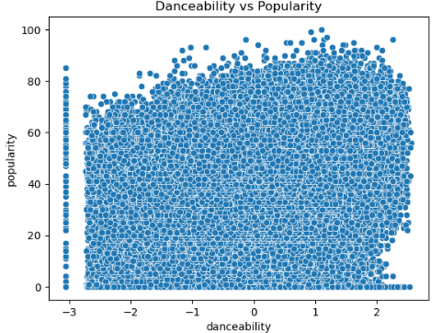
This scatter plot displays the relationship between a song’s danceability score and its popularity. A visible positive trend suggests that tracks with higher danceability tend to achieve greater popularity. This reinforces danceability as a strong predictor in popularity modeling. The wide distribution also highlights that popularity is influenced by additional interacting features
Figure 4: Predicted vs Actual Popularity (XGBoost)

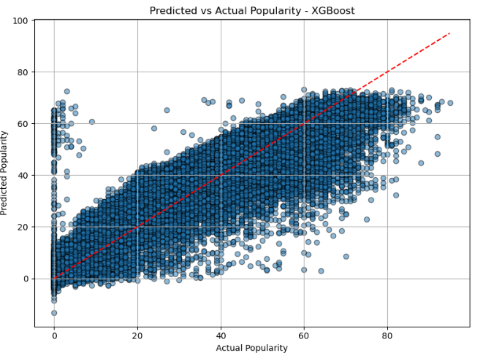
This scatter plot compares the predicted popularity scores against the actual values using the XGBoost model. Most points cluster near the diagonal, indicating strong predictive alignment. However, underestimation is noticeable at higher popularity values, reflecting the model’s challenge in capturing extreme highs. Overall, the trend shows XGBoost effectively models mid-range popularity with reasonable accuracy.

8. Conclusion
This project yielded several key findings that offer valuable insights:
- Random Forest Regressor consistently delivered the best performance with R² = 0.68, MAE = 7.6, and RMSE = 10.1.
- Ensemble models such as XGBoost and Gradient Boosting also achieved strong results.
- Simpler linear models lacked the capacity to capture complex feature interactions.
- SHAP analysis validated that danceability, energy, and valence were top predictors of popularity.
The project demonstrates that machine learning can effectively predict music popularity based on audio features, offering valuable applications for artists, producers, and platforms.

8.1 Practical Implications
- Artists: Optimize song composition with feature-based feedback.
- Streaming Platforms: Improve recommendation algorithms using popularity predictions.
- Marketers: Identify potential hit songs early.
- Record Labels: Allocate resources more effectively using data insights.

9. Future Work
- Add features like artist follower count or social media buzz.
- Perform sentiment analysis of lyrics using NLP models.
- Incorporate advanced explainability tools (e.g., LIME).
- Build a web dashboard to allow real-time popularity predictions.
10. References
[1] Spotify API Documentation
[2] Scikit-learn Documentation
[3] Kaggle Dataset: Spotify Track Data
[4] Lundberg, S. et al. (2020). SHAP: Explainable ML
[5] Géron, A. (2019). Hands-On ML with Scikit-Learn, Keras & TensorFlow
[6] Chen, T. & Guestrin, C. (2016). XGBoost: A Scalable Tree Boosting System
[7] Goodfellow, I., Bengio, Y., & Courville, A. (2016). Deep Learning. MIT Press
[8] Kuhn, M., & Johnson, K. (2013). Applied Predictive Modeling. Springer
[9] Ribeiro, M. T., Singh, S., & Guestrin, C. (2016). Why Should I Trust You? LIME Methodology

